**CHAPTER 1**

**Introducing Flutter and Getting Started**

In this chapter, I focus on the essential steps for installing Flutter, ensuring that I have a fully functional development environment to begin my journey. Flutter, a robust UI toolkit, requires proper setup to enable seamless development of natively compiled applications for mobile, web, and desktop platforms. Setting up Flutter involves installing the necessary tools, configuring my system, and integrating plugins for efficient coding.

To start, installing the **Flutter SDK** is the primary step. The SDK provides all the tools and libraries needed to develop Flutter applications. For Windows users, this involves downloading the Flutter ZIP file from the official website, extracting it to a suitable location, and adding it to the system’s PATH variable to enable global access.

Once the SDK is installed, setting up an **IDE** is crucial for a productive workflow. Popular choices include Visual Studio Code. After installing the IDE, the next step is to integrate the **Flutter and Dart plugins**, which enhance the development experience by enabling syntax highlighting, code completion, and debugging features.

For mobile development, installing **Android SDK** is required for Android applications. Both tools allow us to build, test, and run applications on their respective platforms. Additionally, enabling device emulators or connecting physical devices ensures a smooth testing environment.

Finally, configuring an editor in my **Visual Studio Code** provides a lightweight yet powerful environment for Flutter development. Installing the Flutter and Dart extensions in VS Code makes it easy to create, debug, and test Flutter applications. Once all these tools are set up, running the flutter doctor command checks the installation and ensures that all components are correctly configured. This step helps identify and resolve any missing dependencies or configurations.

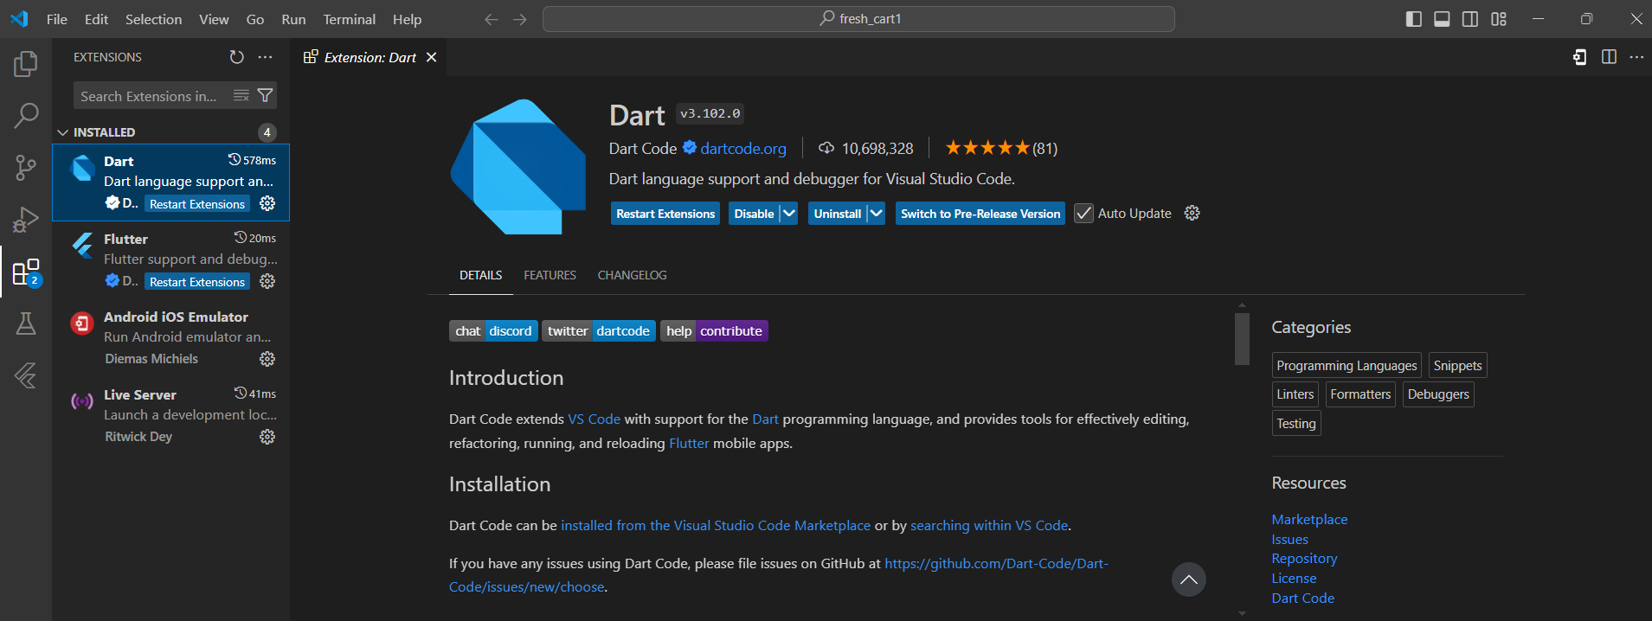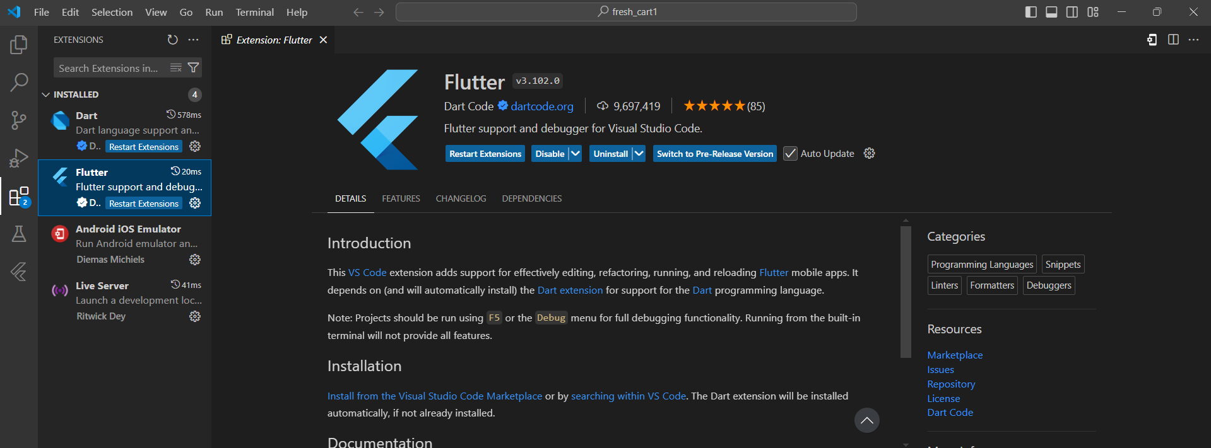By following these installation steps, I can establish a robust development environment, laying the groundwork for building and running Flutter applications. Proper setup ensures a smooth and efficient workflow as you dive deeper into Flutter development.